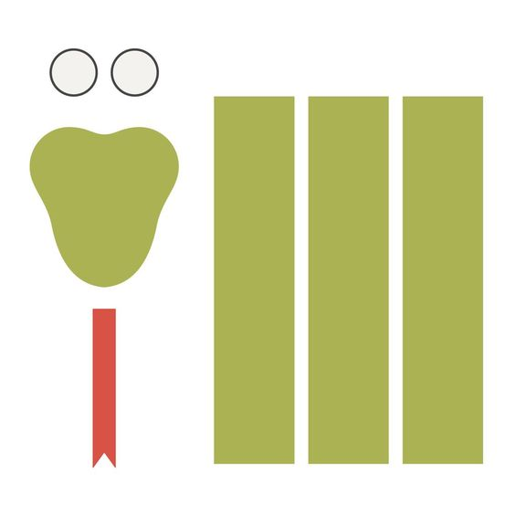

My Snake Can Slither All Around

You will need:
Scissors, construction paper, tape, pen/marker.

Song Lyrics:

Look at my snake

My slithery snake

What can he do?

What sounds can he make?

My snake can:

1: Slither in the grass,

2: Hiss in the air,

3: Hide in my boot,

4: Rattle like a shaker,

5: Live under a rock.

And my snake can slither all around all around

My snake can slither all around.

